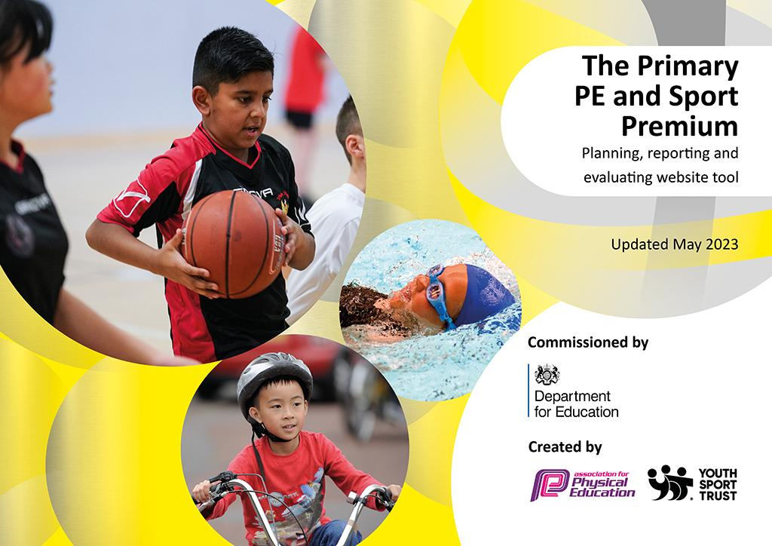
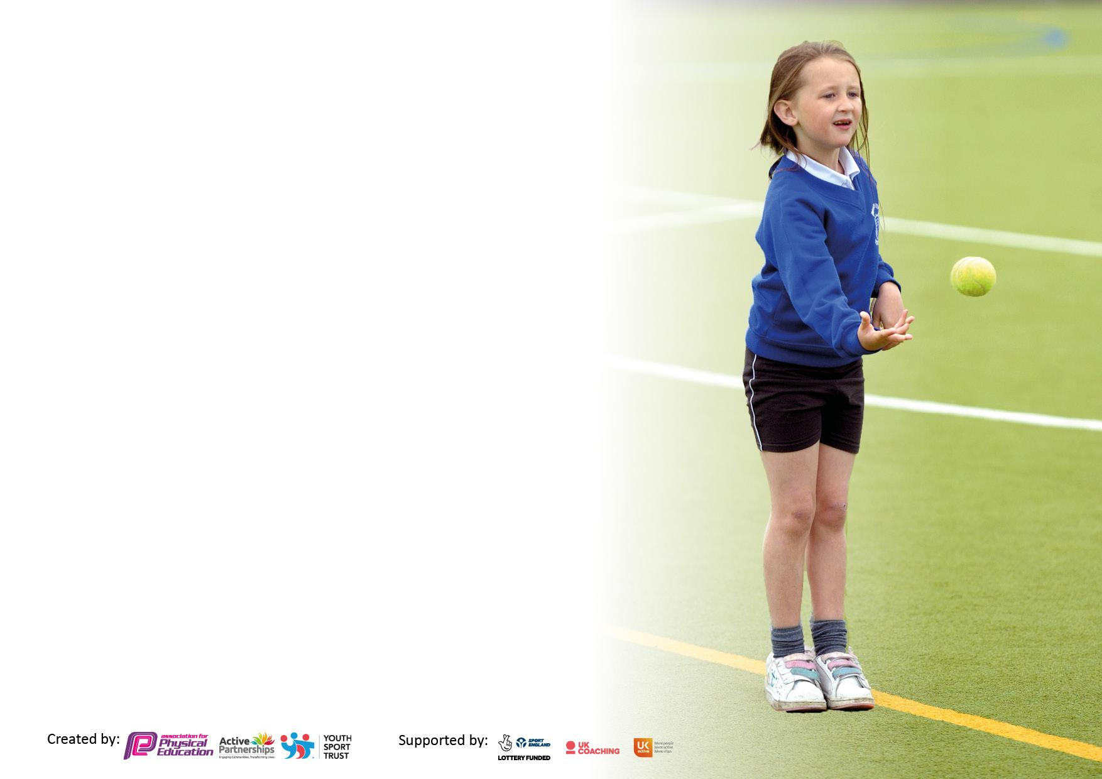

It is important that your grant is used effectively and based on school need. The Education Inspection Framework makes clear there will be a focus on ‘whether leaders and those responsible for governors all understand their respective roles and perform these in a way that enhances the effectiveness of the school’.

Under the Quality of Education Ofsted inspectors consider:
Intent - Curriculum design, coverage and appropriateness
Implementation - Curriculum delivery, Teaching (pedagogy) and Assessment
Impact - Attainment and progress

To assist schools with common transferable language this template has been developed to utilise the same three headings which should make your plans easily transferable between working documents.

Schools must use the funding to make additional and sustainable improvements to the quality of Physical Education, School Sport and Physical Activity (PESSPA) they offer. This means that you should use the Primary PE and sport premium to:

- Develop or add to the PESSPA activities that your school already offer
- Build capacity and capability within the school to ensure that improvements made now will benefit pupils joining the school in future years
- The Primary PE and sport premium should not be used to fund capital spend projects; the school’s budget should fund these.

Pleasevisitgov.ukfortherevisedDfEguidanceincludingthe5keyindicatorsacrosswhichschoolsshoulddemonstrate animprovement.Thisdocumentwillhelpyoutoreviewyourprovisionandtoreportyourspend.DfEencouragesschools to use this template as an effective way of meeting the reporting requirements of the Primary PE and Sport Premium.

We recommend you start by reflecting on the impact of current provision and reviewing the previous spend.

Schools are required to publish details of how they spend this funding, including any under-spend from 2021/2022, as well as on the impact it has on pupils’ PE and sport participation and attainment. All funding must be spent by 31st July 2023.

We recommend regularly updating the table and publishing it on your website throughout the year. This evidences your ongoing self-evaluation of how you are using the funding to secure maximum, sustainable impact. Final copy must be posted on your website by the end of the academic year and no later than the 31st July 2023. To see an example of how to complete the table please click HERE.
Details with regard to funding
Please complete the table below.

Total amount carried over from 2021/22 | £0
Total amount allocated for 2021/22 | £19,380
How much (if any) do you intend to carry over from this total fund into 2022/23? | £0
Total amount allocated for 2022/23 | £18,744
Total amount of funding for 2022/23. To be spent and reported on by 31st July 2023. | £18,744
Swimming Data
Please report on your Swimming Data below.

Meeting national curriculum requirements for swimming and water safety.

N.B. Complete this section to your best ability. For example you might have practised safe self-rescue techniques on dry land which you can then transfer to the pool when school swimming restarts.
Due to exceptional circumstances priority should be given to ensuring that pupils can perform safe self rescue even if they do not fully meet the first two requirements of the NC programme of study
What percentage of your current Year 6 cohort swim competently, confidently and proficiently over a distance of at least 25 metres?  N.B. Even though your pupils may swim in another year please report on their attainment on leaving primary school at the end of the summer term 2022.  Please see note above | 61%  37/61
What percentage of your current Year 6 cohort use a range of strokes effectively [for example, front crawl, backstroke and breaststroke]?  Please see note above | 61%  37/61
What percentage of your current Year 6 cohort perform safe self-rescue in different water-based situations? | 90%
Schools can choose to use the Primary PE and sport premium to provide additional provision for swimming but this must be for activity over and above the national curriculum requirements. Have you used it in this way? | No

Action Plan and Budget Tracking
Capture your intended annual spend against the 5 key indicators. Clarify the success criteria and evidence of impact that you intend to measure to evaluate for pupils today and for the future.

Academic Year: 2022/23 | Total fund allocated: £18744 | Date Updated:
Key indicator 1: The engagement of all pupils in regular physical activity – Chief Medical Officers guidelines recommend that primary school pupils undertake at least 30 minutes of physical activity a day in school |  |  |  | Percentage of total allocation:
 |  |  |  | %
Intent | Implementation |  | Impact
Your school focus should be clear what you want the pupils to know and be able to do and about  what they need to learn and to  consolidate through practice: | Make sure your actions to achieve are linked to your intentions: | Funding allocated: | Evidence of impact: what do pupils now know and what can they now do? What has changed?: | Sustainability and suggested next steps:
PE Lesson  All pupils take part in a minimum of 1 hour of physical activity per week during a PE lesson, including a rotation of Beth Tweddle Lessons. Curriculum Swimming Y6  Daily Mile  All pupils can access the “Daily Mile” National initiative which the school are part of. 15 minute desk to desk brisk walk or run on the playground or within the school building each day, as and when the teachers feel the children will benefit.  Active lunchtimes  10 sports leaders timetabled across playgrounds during lunchtimes. PE Lead monitors their engagement and pupils.  Clubs  Y1-Y6 pupils have access to physically active clubs after school  Equipment  Purchase equipment that can be used at break times to encourage children who do not want to play team games. | Staff training on Real PE and Daily Mile Initiative  Knowsley 8 day, 2 week consecutive swimming lessons with Knowsley instructors and trained school staff  Beth Tweddle and Happy Hedgehog Gymnastics lessons, 1 year group per term on a 2 year rotation.  Lunchtime supervisors and sports leaders are trained to deliver activities.  Clubs are advertised and promoted through Arbor, email, letters, assemblies about Prescot Pilots and Twitter  Purchased equipment that encourages children to practice core skills  e.g. throwing, catching, balance, jumping etc | £1450  £1637 | Children enjoy having a brain break and can talk about how it helps them focus on their work better. It also acts as a reminder for the children to drink water afterwards which promotes a healthy lifestyle.  Lesson plans online.  PE Lead “drop in” lessons and feedback from teachers and children.  Swimming data  Video and photographs on Twitter | Daily mile track.  We are training up play leaders who can get children active with the equipment available.  Try to get full registers in the younger years too. Ask the children why they don’t come to clubs? Is there something we can do to make the clubs more appealing?  Developing club links to increase the amount of clubs on offer.
Key indicator 2: The profile of PESSPA being raised across the school as a tool for whole school improvement |  |  |  | Percentage of total allocation:
 |  |  |  | %
Intent | Implementation |  | Impact
Your school focus should be clear what you want the pupils to know and be able to do and about  what they need to learn and to  consolidate through practice: | Make sure your actions to achieve are linked to your intentions: | Funding allocated: | Evidence of impact: what do pupils now know and what can they now do? What has changed?: | Sustainability and suggested next steps:
Engage with local primary schools to allow children to enjoy a range of sports.  Give students confidence to try sports they do not feel confident in.  Give students the opportunity to compete at every level.  Use sport as a tool to assist with SEND.  Use sport as a tool to assist with transitions.  Track pupils attainment and commitment to activites | Engage with local primary schools to create additional opportunities for B and C squad competitions in sports. For example cross country and dodgeball with Evelyn CP (walking distance).  Engage with Knowsley School Sport Partnership to access their competition calendar including at least 4 SEND competitions.  Sports week provides opportunities for nursery to Y6 to demonstrate their physical abilities, and engagements activities with parents.  Annual whole school engagement with National fundraising initiatives  Use of Prescot Pilots to celebrate the commitment of all children in and out of school. | £500  £650  £800 | Feedback from parents to say they enjoy seeing their children participating in PE.  Raising awareness of the importance of mental health and promoting social skills. | Monitor the success of REAL PE with observations and interviews.  Increase the amount and variety of clubs for the children to choose from.  Increase the amount of competitions

Key indicator 3: Increased confidence, knowledge and skills of all staff in teaching PE and sport |  |  |  | Percentage of total allocation:
 |  |  |  | %
Intent | Implementation |  | Impact
Your school focus should be clear | Make sure your actions to | Funding | Evidence of impact: what do | Sustainability and suggested
what you want the pupils to know | achieve are linked to your | allocated: | pupils now know and what | next steps:
and be able to do and about | intentions: |  | can they now do? What has
what they need to learn and to |  |  | changed?:
consolidate through practice:
PE lead to train staff old and new.  Inset Day training for staff  Weekly CPD for gymnastics | Real PE Scheme tried and tested by PE Lead and PE Team in previous years and recommended.  Real PE online scheme and training for staff  Beth Tweddle and Happy Hedgehog Gymnastics lessons. 1 year group every term have access to gymnastics delivered by experts.  Class teachers assist in the lessons and gain CPD for gymnastics. | £950  £2475 | Google Forms for children and staff  Photos and videos on Twitter  PE Lead to be released from class to support in lessons were necessary on request  Demonstration and support of lesson delivery by P.E lead | Time out of class for PE Lead to quality assure the delivery of the PE Curriculum, and the manage clubs, competitions and Prescot Pilots initiative.
Key indicator 4: Broader experience of a range of sports and activities offered to all pupils |  |  |  | Percentage of total allocation:
Intent | Implementation |  | Impact
Your school focus should be clear | Make sure your actions to | Funding | Evidence of impact: what do | Sustainability and suggested
what you want the pupils to know | achieve are linked to your | allocated: | pupils now know and what | next steps:
and be able to do and about | intentions: |  | can they now do? What has
what they need to learn and to |  |  | changed?:
consolidate through practice:
For all children to experience a wide range of sports through high quality teaching.  To use those skills to compete in interschool competitions.  The children have been able to obtain athletic skills from trained coaches.  Morning clubs to keep children active in the mornings.  Encourages resilience, teamwork and independence.  Teach children self defence skills and ability to experience sports not readily available. | We purchased a planning scheme through Real P.E. We have tailored this to our school/ children’s needs.  We have been able to have competition across year groups at the end of units of work and are hoping to cross year groups this summer term.  Liverpool harrier in school to provide Athletics training for Year 6..  Early morning running and dodgeball club. Linked to KSSP competitions.  Adventurous activities (PGL) for Y6 3 night, 4 day stay in September  Adventurous activities for Y4 1 night 2 day stay in February.  Judo, fencing and archery all available as clubs. | £695  £1500  £500  £850 | Attendance figures for clubs and overnight stay activities  Twitter  Feedback surveys from pupils, parents and staff. | Offer sports that children cannot experience in school.  Make more links with local clubs and societies.  Time out of class for PE Lead to quality assure the delivery of the PE Curriculum, and the manage clubs, competitions and Prescot Pilots initiative.  Continue to maintain high participation numbers in clubs.

Key indicator 5: Increased participation in competitive sport |  |  |  | Percentage of total allocation:
 |  |  |  | %
Intent | Implementation |  | Impact
Your school focus should be clear | Make sure your actions to | Funding | Evidence of impact: what do | Sustainability and suggested
what you want the pupils to know | achieve are linked to your | allocated: | pupils now know and what | next steps:
and be able to do and about | intentions: |  | can they now do? What has
what they need to learn and to |  |  | changed?:
consolidate through practice:
SLA Knowsley School Sports Partnership  Links with local schools in the main Evelyn CP  Sports week: House colour competitive races for KS2  Inter year group competitions | Yearly calendar of competitions to enter for the KSSP.  At least one event per term organised with Evelyn CP for example cross country.  Summer term National Sports week.  Y3 and Y4 sports day sand Y5 and Y6 sports days in that week are competitive.  Inter year group competitions are organised at least once a year to compliment PE lessons | £1350  £200  £400 | Children have enjoyed competing in a variety of sports, some they have never tried before. It has enabled us to practice a range of skills.  Girls football competitions KSSP  Mixed football competitions KSSP  Cross country competitions KSSP  Everton in the community football competition.  Photographs on school sport Twitter account. | Continue to develop the range of competitions available for all children.  To set up competition with more schools within walking distance or offer our school as a venue for the competitions.

Signed off by
Head Teacher: | Steve George
Date: | 17.07.23
Subject Leader: | Gareth Dobson
Date: | 17.07.23
Governor:
Date:

